

Bridgebuilders Trust Inc

New Zealand

Issue 1 Vol. 1 Newsletter December 2018

# Greetings from the President



***To you is born this day … a Savior who is the Messiah, the Lord***

Reading from Luke 2:8 announce the birth of Jesus. As we prepare to celebrate the birth of Jesus wherever we are we give thanks for his rich blessings. And so, as 2018 draws to a close we give thanks for the opportunity to serve His church as members of the Bridgebuilders Network.

It has been my privilege to lead our Trust as President. This has been a year of building, reconnecting and starting new relationships in our local community. I had the opportunity to attend CAB, Onehunga Community meeting in March and connected with some old friends.

We have taken part in several community events promoting our work as a Trust. We had two opportunities to participate and provided two information stalls at the Auckland Multicultural Society Inc, Multicultural Expo 2018 in August. We displayed our leaflets and spoke to the local community about our work as Bridgebuilders. This was a joyful, blessed day filled with laughter especially enjoyed by my parents Mr & Mrs Tauetule and Aunty Mine. They happily took the lead in the dancing and getting up on the stage; my family didn’t need to be dragged onto the stage. They were the first ones on the stage – Diva’s! The second opportunity was on the 22nd September at the Universal Peace Foundation – UN International Day of Peace 2018, celebration. This was well attended by over 100 participants from diverse religious and ethnic backgrounds gathered for the event. And enriched by a number of dedicated charitable and religious organisations with display tables, we were able to share with everyone our work and how we serve in the communities.

2018 marked 125 years since New Zealand women won the right to vote on 19 September 1893. To remember this day and in celebration we paid tribute to Jane Prichard with a High Tea afternoon. This was a delightful day lead by Rev. Marie Ropeti-Apisaloma in a conversation with Jane about her life journey as a woman, a leader of many women’s orgainsation and founder of various women’s orgainsation.

Jane’s achievements and life service is an inspiration to all women young and old. She has championed many causes and projects through raising awareness of women’s rights and responsibilities. Jane works for a betterment of society by development that is people centered and sustainable. Jane retired from the Trust in 2010; however she continues to support the work of Bridgebuilders Trust.

The Bridgebuilders Trust is blessed for having strong women on its board; Jan Ngatae, Viv Wilson, Rev. Marie Ropeti-Apisaloma, Rev. Lorraine Francis, Isabella Tedcastle, MNZM, Patron Jane Prichard, QSO, Ana Siafa, Haele Siafa and Dorothy Alofivae. I wish to thank each and every one of you for your support, time and commitment to the work of Bridgebuilders.

Just knowing we stand together has been very empowering. That together we build bridges and open new doors knowing that with God’s help all things are possible.

Blessing to you all this Advent season

Rose Tauetule

President

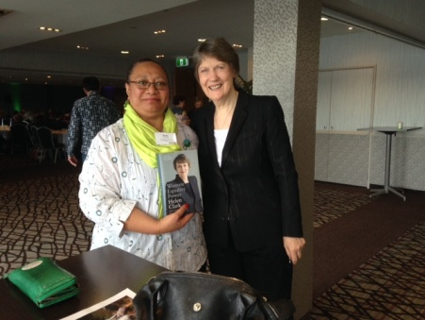

2018 Events

CAB Community Meeting, Onehunga, March

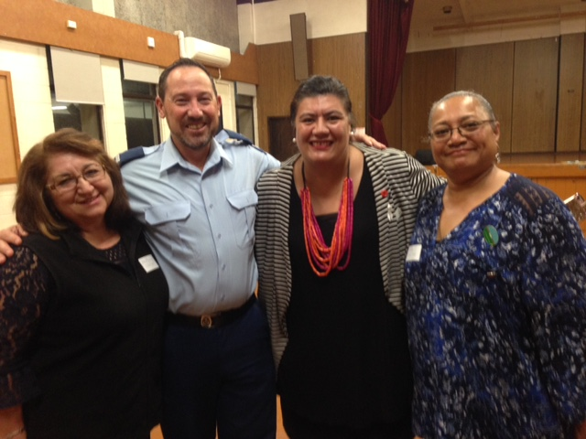

Bridgebuilders Trust Annual General Meeting, June

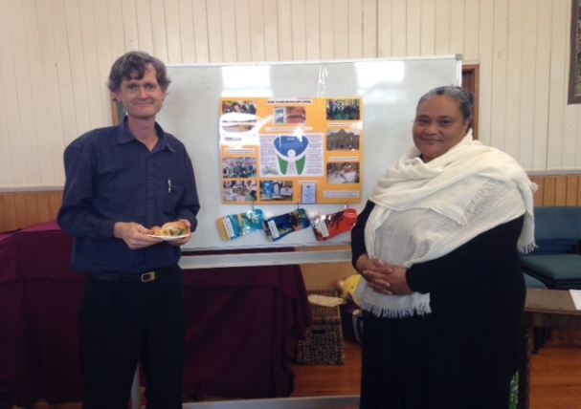

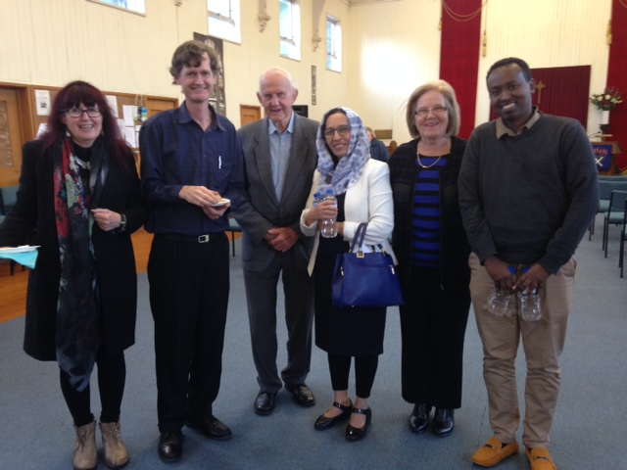

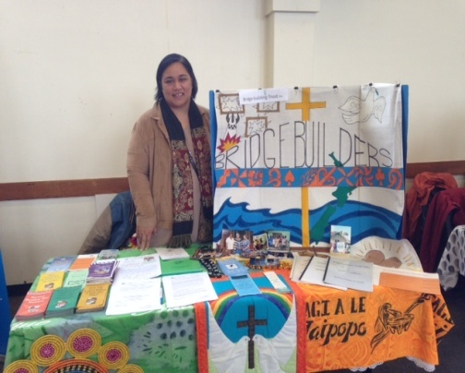

Auckland Multicultural Society Inc

10th Multicultural Expo 2018

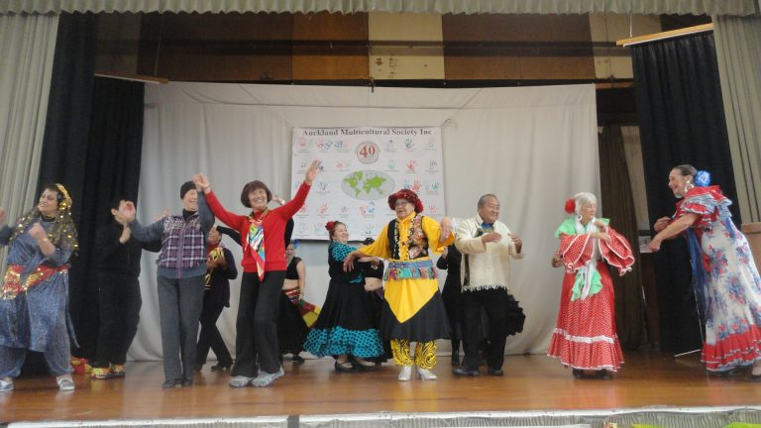

Dancing queen’s again centre stage Mrs Taha Tauetule

Universal Peace Federation

UN International Day of Peace 2018 Celebrations

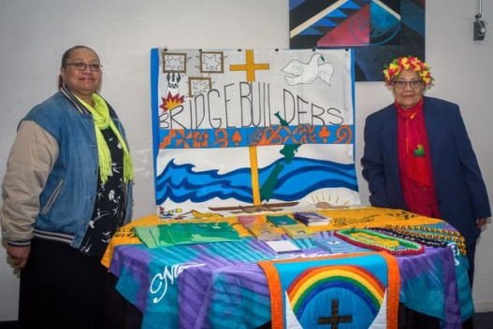

Display table for Bridgebuilders with

Mrs Taha Tauetule (mum)

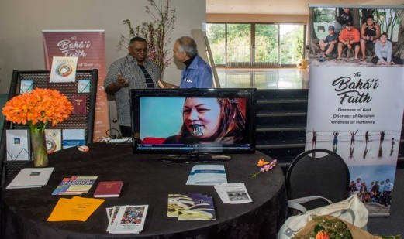

Display table for Baha’i Faith

125 Years – Women’s Suffrage

High Tea Celebration in honour of Jane Prichard, QSO

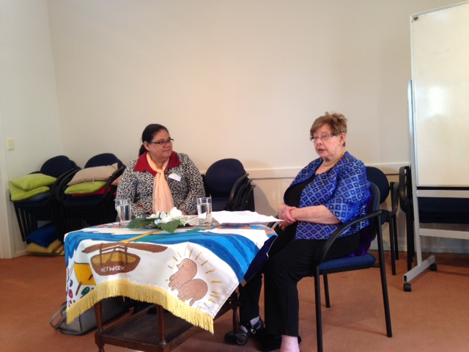

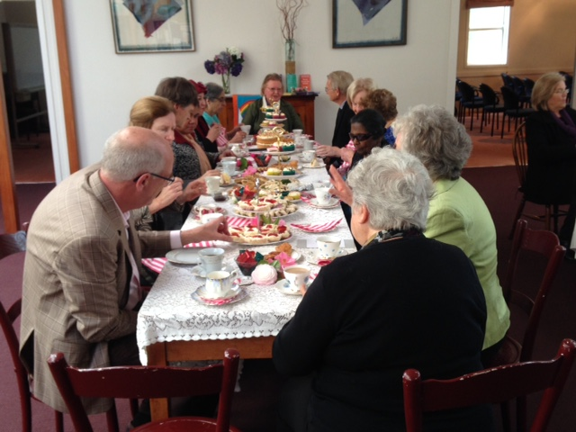

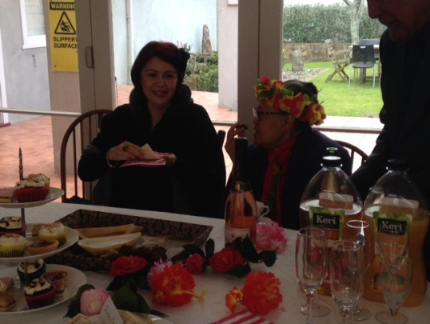

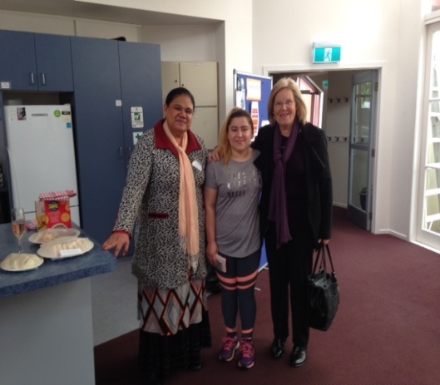

High Tea

PWW (NZ) Half Day Conference United Nation’s

Jane Prichard, presenting on ECSCO Status application

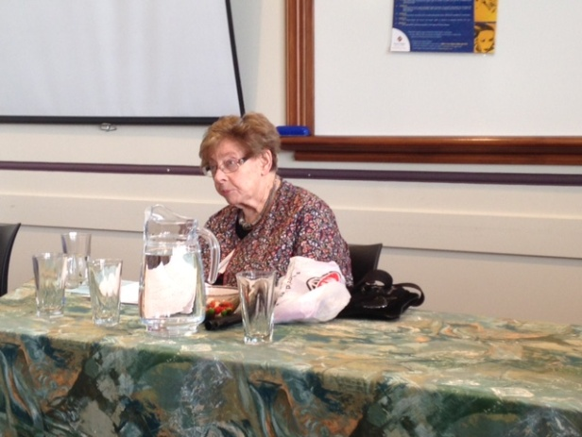

**Bridgebuilders** seeks to include both Christian and secular women in a Network transforming in a spirit of service to ensure that Human rights are universal, environmental development will be people-cantered, sustainable and ecologically sound, justice and peace are achieved for all people.

**Bridgebuilders** take action to Advance Christian faith-sharing and outreach, exchange information, identify and be involved with national and global issues, join together in friendship, share resources and exchange personnel, raise awareness of women’s rights and responsibilities in a communication system of fast and efficient dialogue within the broad region of the Pacific Basin.

***If you have anything that you would like published in Newsflash, please feel free to forward any material via email, post or drop it in to us.***





Office Manager’s Report

The office is open on Monday and Tuesday from 9am to 12pm. I am working in updating the office space and replacing the old photocopier. The storage room needs reorganizing and this is on my list for 2019, all volunteers are welcome to help out. Our old blind has been replaced by Jane and we are most grateful for her generosity.

I am blessed to be working in our office, since leaving the banking industry after 32 years. This role has given an opportunity to look at community work with great respect. 2019 will be new goals and plans to achieve. I encourage you to drop in if you’re passing by and say hello and have a coffee. I want acknowledge our friends, families and the Auckland Chinese Presbyterian Church for making donations of clothing, household goods, food parcels and sports gears and

especially monetary gifts to help support our Refugee families.

Thank you to Viv Wilson and Jane Prichard who visit the office regularly.

Rose Tauetule, Office Manager

**Community Project: ‘Family Teeth Matters’**

In partnership with Family Teeth Matters we are supporting this important Free Dental Health Education programme founded by Cynthia Wallbridge and Dr David Wallbridge. A community based programme for lower decile Early Childhood Centers and Primary Schools. The aim is to improve the awareness and outcomes of child dental health through quality preventive dental education using a family based model. To help fund the Dental Health Project Box financial donations and sponsorship are most welcomed. We strongly support this programme for its forward thinking and the positive impact it will have on the family and reducing the decay in our children’s teeth. And help reduce the cost to our health system. I want to acknowledge Mr Wayne Chan, Tai Ping Trading for his generous sponsorship of a Dental Health Project Box for a Primary School; this will be implemented in 2019.

Please call the office or contact Cynthia Wallbridge direct: mobile 027 3814 836 or by email: [Cynthia@familyteethmatters.nz](mailto:Cynthia@familyteethmatters.nz) for further details or to make a generous donation for a Dental Health Project Box.

**Refugee Family Support**

The number of families referred to the Trust for assistance and help continues to increase yearly. The support we offer our families would not be possible if not for the tireless and unwavering commitment by Viv Wilson and committee members. We have supported our families through mentoring, transporting, delivering, listening and obtaining equipment all led by Viv Wilson. This support is also with the help our Bridgebuilding friends Mr & Mrs Nicholson. It is a valuable service of outreach and to build relationships with new, New Zealander, as they being to adapt to living in a country different to their own homelands.



**The Bridge**

There are times in life

When we are called to be bridges,

Not a great monument spanning a distance

And carrying loads of heavy traffic,

But a simple bridge to help one person from here to there over some difficulty such as pain, grief, fear, loneliness, a bridge which opens the way for ongoing journey

When I become a bridge for another,

I bring upon myself a blessing, for I escape from the small prison of self and exist for a wider world, breaking out to be a larger being who can enter another’s pain and rejoice in another’s triumph.

I know of only one greater blessing in this life and that is, to allow someone else to be a bridge for me.

**Joy Cowley**

**‘’Aotearoa Psalms’’**

(Reprinted with the permission of the publisher Catholic Supplies (NZ) Ltd, 80 Adelaide Rd, Wellington, New Zealand

###### Membership fees

Thank you to the members and organizations that have sent their membership fees. If you have not yet paid your annual membership. Please send in your payment of $20, this assist with cost of newsletter distribution, administration and communication by the office. Please note that when making payment the name of the banking account is: - BRIDGEBUILDERS TRUST INC

ASB BANK, BLOCKHOUSE BAY BRANCH, 519 BLOCKHOUSE BAY ROAD, BLACKHOUSE BAY, AUCKLAND, NEW ZEALAND

ACCOUNT NO: 12-3049-0300526-00

**REFERENCE: (please your name)**

**Board of Officers 2018-2019**

**Patron: Jane Prichard, QSO**

**President: Rose Tauetule**

**Mobile: 021-618716**

**Secretary: Viv Wilson**

**Treasurer: Jan Ngatae**

**Committee**

**Rev. Marie Ropeti-Apisaloma**

**Rev. Lorraine Francis**

**Isabella Tedcastle**

**Dorothy Alofivae**

**Ana Siafa**

**Haele Siafa**

**Address: 70 Khyber Pass Road, Auckland**

**Phone: 09 307 0701**

**Email:** [**bridgebuildestrust@xtra.co.nz**](mailto:bridgebuildestrust@xtra.co.nz)

**Website:** [**www.bridgebuilders.org.nz**](http://www.bridgebuilders.org.nz)

**Schedule of Events**

***Project planning meeting***

***31 Jan 2019***

***Venue: Owairaka Pacific Islanders Church***

***Bridgebuilders Trust Inc***

***Board meeting***

***19 Feb 2019***

***Venue: St David’s Church Centre***

***7pm***



*Bridgebuilders Trust wish you all a Peaceful, Loving, Safe and happy joyful Christmas.*

*May the New Year be filled with good health and with many blessings****.***

I will be away from the office from 13/12/2018 and return 20/12/2018. The office will close and reopen 14/01/2019.