

Bridgebuilders Trust Inc

New Zealand

Issue 1 Vol. 1 Newsletter December 2019

# Christmas Greetings from the President



*As we celebrate the birth of Jesus may we rejoice in the love, hope, peace and joy of God’s loving Grace. We wish you and your families a joyous Christmas celebration with many blessing in 2020.*

It has been my privilege once again to lead our Trust as President. This has been another year for the Trust to continue to build relationships and connections within our local community.

We have taken part in several community market stalls to sale our jam’s and baked goods. The first market stall was at Somervell Presbyterian OPp Art Display event. The images feature selected works by artists who engage elements of upcyclying in their craft. This exhibition started as a Somervell Op Shop initiative to creatively promote the care of our planet. The second opportunity was at the International Christmas Stall day at St Heliers Presbyterian church, once again another successful day selling our baked goods and yummy jams. This success continues with a highly attended movie evening held at Somervell Presbyterian Church. With the screen of the movie *Dumplin.*  These events have given the Trust a platform to promote our education leaflets for families and to be seen in the community. As well as fund raising for our ongoing community projects.

Umma Trust and Bridgebuilders Trust had a joint Faith celebration for the *Breaking of fast: Interfaith Iftar.* The Trust had an opportunity to share in prayer and to speak about the work we do as Bridgebuilders in our local community and to outline our long association with the Umma Trust. This evening was well attended by all the different faith groups and various local community groups.

***2019 will be a memorable year for Jane Prichard and myself. We were both recognised and honoured with Queens Honours Award. Jane received a CNZM for her work with women church groups, establishing new organisations and for CEDAW. I was honoured with a Queens Service Medal for working with Womens Groups and Niuean Community. These awards are a blessing and honour.***

The Bridgebuilders Trust welcomed new members elected at our Annual General Meeting: Lindsay Smith, Jacqueline Lakatani and Amelia Fakalaga. I wish to acknowledge every one for your support, time and commitment to the work of Bridgebuilders.

By standing together we are empowered. That we ensure our voices are heard and we uplift all people needing our help. That together we build strong bridges knowing that through Gods help all things are possible.

Blessing to you all this Advent season

Rose Tauetule, QSM

President

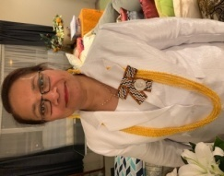



*Our People & Events 2019*

Investiture Ceremony

Jane Prichard, CNZM, QSO and Rose Tauetule, QSM

Queens Honours Award 2019

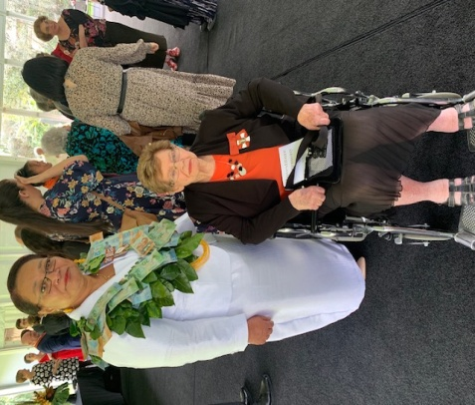

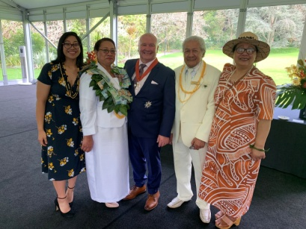

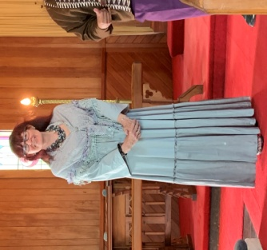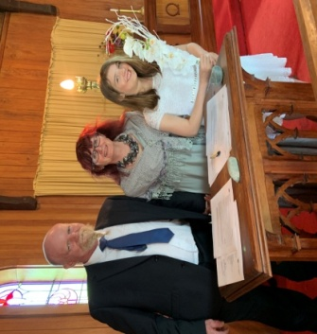

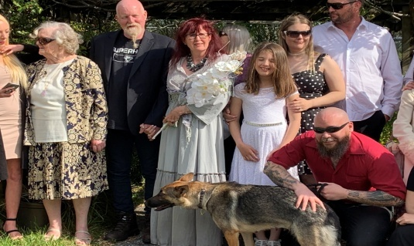

Jan and Kevin’s Special wedding day shared with families and close friends. It was a beautiful day. It was an honour to witness two amazing people pledged their love for each

Reception Evening with HRH Prince Charles and the Duchess of Cornwall, October 19th 2019

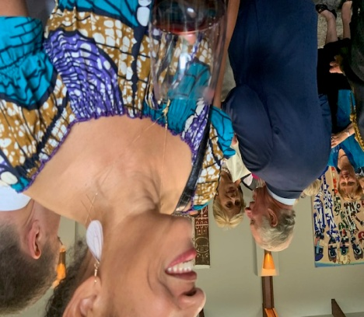

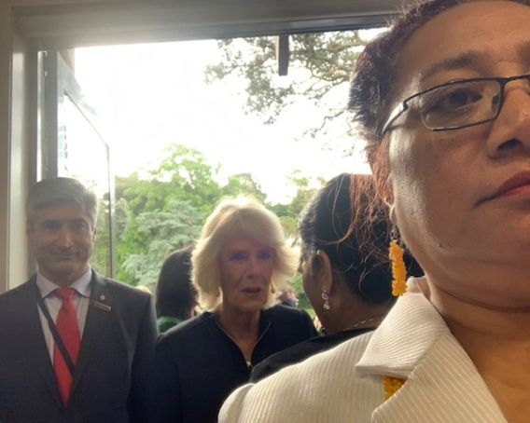

PWW (NZ) Half Day Conference

Discussion of a Constitution for Aotearoa New Zealand

Fala Haulangi

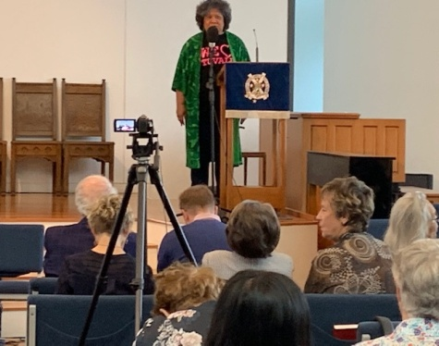

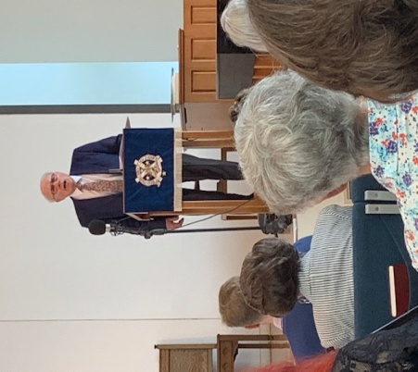

Sir Geoffrey Palmer



***Bridgebuilders*** *seeks to include both Christian and secular women in a Network transforming in a spirit of service to ensure that Human rights are universal, environmental development will be people-cantered, sustainable and ecologically sound, justice and peace are achieved for all people.*

***Bridgebuilders*** *take action to Advance Christian faith-sharing and outreach, exchange information, identify and be involved with national and global issues, join together in friendship, share resources and exchange personnel, raise awareness of women’s rights and responsibilities in a communication system of fast and efficient dialogue within the broad region of the Pacific* *Basin.*

***If you have anything that you would like published in Newsflash, please feel free to forward any material via email, post or drop it in to us.***

Office Manager’s Report

The office is looking at purchasing a new photo copier. We are waiting to update our posters from the Peace Foundation and Breast Screening New Zealand. We continue to keep the office and the store room tidy. This office space is shared with Pacific Women’s Watch New Zealand.

Rose Tauetule, QSM

Office Manager

**Community Project: ‘Family Teeth Matters’**

The partnership we have with *Family Teeth* *Matters* continues. Our ongoing support for this important Free Dental Health Education programme founded by Cynthia Wallbridge and Dr David Wallbridge has been well received in the community. To help fund the Dental Health Project Box financial donations and sponsorship are most welcomed. The long awaited book *Detective Sugar Spotter* written and illustrated by Anne-Marie MacIntyre is now available for purchase. We support this programme for its forward thinking and the positive impact it will have on the family and reducing the decay in our children’s teeth. And help reduce the cost to our health system. Please call the office or contact Cynthia Wallbridge direct: mobile 027 3814 836 or by email: [Cynthia@familyteethmatters.nz](mailto:Cynthia@familyteethmatters.nz) for further details or to make a generous donation for a Dental Health Project Box or to purchase the new *Detective Sugar Spotter Book.*

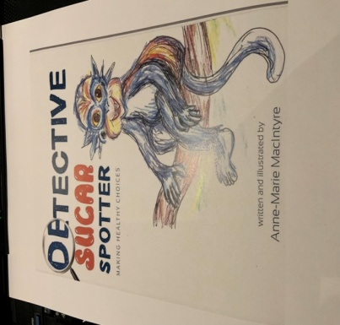

**Refugee Family Support**

The support we offer our families would not be possible if not for the hard work and commitment by Viv Wilson and committee members. We continue to support our families through mentoring them, with transporting, and deliveries of food and home furniture led by Viv Wilson and friends. We continue to receive tremendous support and from our Bridgebuilding friends Mr & Mrs Nicholson. It is a valuable service of outreach and to build relationships with new, New Zealander, as they being to adapt to living in a country different to their own homelands.

**Update on our Young Family**

I have been assisting Anna with her Academic English course at MIT. Anna is a bright and determined young woman. They meet in Papatoetoe library twice a week. Anna has recently passed level 4 and has been awarded a police scholarship for her Level 5 study in 2020. If successful, Anna will be able to start training with the Police in the second half of the year at Manukau. She will have to work on her mathematics as well, which Lindsay will also support her with.

2019 has been a rewarding and exciting year for Anna. In February she married Mike, who has been a tremendous support for her, and behaves as a father towards Mehdi her eight year old son. He regularly helps prepare food for those in need at his local temple. Later in the year she passed her driving test (in Lindsay’s car!)

In November she was interviewed on Stuff.co.nz as a settling refugee, which had hundreds of likes. In addition her English language teacher invited Anna to accompany her to fly to Wellington to attend a conference to gather suggestions for how NZ can improve its settlement of refugees. She did not contribute to this, but instead gave an impromptu thank you for all the support she has had since arriving here which touched everyone there. Finally, just in time for Christmas she received notification that she has been allocated a house in Mount Roskill! She and her family had been living in one room for six months which must have made studying very difficult. With great joy she moves in on 21st December. It is opposite the local primary school and backs onto a park. Praise the Lord!

**A prayer**

Heavenly Father, we with us this and every day  
As we travel on our way  
Grant us such a vision of your love that  
No task may seem too demanding  
No path too difficult to tread  
No journey too long  
And bring us home at last to your eternal kingdom,  
Through Jesus Christ our Lord  
Amen

By Lindsay Smith

***The Bridge***

*There are times in life*

*When we are called to be bridges,*

*Not a great monument spanning a distance*

*And carrying loads of heavy traffic,*

*But a simple bridge to help one person from here to there over some difficulty such as pain, grief, fear, loneliness, a bridge which opens the way for ongoing journey*

*When I become a bridge for another,*

*I bring upon myself a blessing, for I escape from the small prison of self and exist for a wider world, breaking out to be a larger being who can enter another’s pain and rejoice in another’s triumph.*

*I know of only one greater blessing in this life and that is, to allow someone else to be a bridge for me.*

***Joy Cowley***

***‘’Aotearoa Psalms’’***

*(Reprinted with the permission of the publisher Catholic Supplies (NZ) Ltd, 80 Adelaide Rd, Wellington, New Zealand*

###### Membership fees

Thank you to the members and organizations that have sent their membership fees. If you have not yet paid your annual membership. Please send in your payment of $20, this assist with cost of newsletter distribution, administration and communication by the office. Please note that when making payment the name of the banking account is: - BRIDGEBUILDERS TRUST INC

ASB BANK, BLOCKHOUSE BAY BRANCH, 519 BLOCKHOUSE BAY ROAD, BLACKHOUSE BAY, AUCKLAND, NEW ZEALAND

ACCOUNT NO: 12-3049-0300526-00

**REFERENCE: (please your name)**

**Board of Officers 2019-2020**

**Patron: Jane Prichard, CNZM, QSO**

**President: Rose Tauetule, QSM**

**Mobile: 021-618716**

**Secretary: Genieva Fakalaga**

**Treasurer: Lindsay Smith**

**Minute Secretary: Viv Wilson**

**Committee**

**Rev. Marie Ropeti-Apisaloma**

**Rev. Lorraine Francis**

**Isabella Tedcastle**

**Dorothy Alofivae**

**Amelia Fakalaga**

**Jacqueline Lakatani**

**Address: 70 Khyber Pass Road, Auckland**

**Phone: 09 307 0701**

**Email:** [**bridgebuildestrust@xtra.co.nz**](mailto:bridgebuildestrust@xtra.co.nz)

**Website:** [**www.bridgebuilders.org.nz**](http://www.bridgebuilders.org.nz)

**Schedule of Events**

***Project planning meeting for 2020***

***To be confirmed***

***Bridgebuilders Trust Inc***

***Board meeting***

***18th February 2020***

***Venue: St David’s Church Centre***

***7pm***

***Bridgebuilders International Taiwan***

***9th Consultation, September 2020***

***Further details to follow***



Bridgebuilders Trust wish you all a Loving, Safe and happy joyful Christmas.

May the New Year be filled with good health and with many blessings***.***

The office will close 27 December 2019 and reopen 27 January 2020